JANUARY 2024 NEWSLETTER
The Howes House
Office Hours: Monday – Friday 8:30 AM- 4:00 PM Closed Holidays
CLOSED MONDAY 1/1
CLOSED MONDAY 1/15

1042A State Rd., West Tisbury MA 02575 (Across from Alley’s)
Phone: (508) 693-2896 Fax: (508) 693-1447

Hello friends ~ January highlights include:

- Weekly luncheon Thursdays at 12:30 Suggested donation $4 -sign up Monday before by noon
- Thursdays in January 4,11,18,25 2-3:30 Live to 100: Secrets of the Blue Zone
- 1ST Wednesday of the month the Off-Island Shopping Trips are back!
- Wednesday 1/13 @ 12 Noon Soup & Table Games
- Wednesday 1/17 @1:30 proCRAFTinators Soap Making
- Monday 1/29 @ 10AM THE RESOURCE INC. Informational Session

Wishing you and yours health and happiness in the new year!

Joyce Albertine, Director
Bethany Hammond, Assistant Director
Susan Merrill, Outreach Coordinator
Jennie Gadowski, Administrative Assistant
Please sign up Mondays by noon - Suggested $4 Donation
THE OFF-ISLAND SHOPPING TRIPS ARE BACK!!!
1st Wednesday of the month
8:15 boat returning 3:45 –meet at the Steamship Authority by 7:30am. You will need to purchase a round trip walk on boat ticket.
Please call the UPICOA to sign up!
508-693-2896
Transportation Services
STOP BY & PICK UP A COPY OF ‘ON THE GO’ SAFE RIDES FOR OLDER ADULTS – SPONSORED BY HEALTHY AGING MV
Go Go Grandparent (Pilot Program from Healthy Aging MV!)
There is a new pilot program called Go Go Grandparent which is fully subsidized to provide on-demand transport for older adults. It is a concierge service that works directly with Uber and Lyft. It does not require that you have an app on your phone - it is all done by a live operator. The Martha’s Vineyard Older Adult Transportation Coalition is piloting this program as well as exploring other solutions for transportation for Older Adults. Please be aware this is piloted towards folks who may not drive anymore and/or meet certain requirements. Call us for more information 508-693-2896

Medivan (VTA)
Medivan to Boston - Tuesdays- 3 times per month call 508-693-9440 ext.1
To participate in the Medivan program, those interested must submit a one-time application through the MVTA. Applications do not require a doctor’s note if passenger is over the age of 60. The Medivan holds 12 passengers and provides service on a first come, first served basis. The van picks up passengers every Tuesday from either the Vineyard Haven Park & Ride at 6:15AM or the VH ferry parking lot at 6:30AM for a 7:00AM ferry to Woods Hole. The van travels to all hospitals within Boston. Doctor’s appointments must be made between 10:00 and 1:00 for a 2:00ish pick-up. Fee is $40.00 round trip, including boat.
Medivan to Ophthalmic Consultants of Boston in Sandwich – One Tuesday per month 508-693-7900 ext. 455 or 800-635-0489 (OCB Sandwich office)

VTA Senior Bus Passes
RIDE FREE NOW THRU MARCH

FOOD RESOURCES:
Monthly Food Distribution the UICOA distributes surplus food sponsored by the Commonwealth of Massachusetts Department of Agriculture. The food to be distributed varies; financial guidelines apply. We try to order a variety of produce and dry goods. Currently our program reaches about 20-25+ senior households in the up-island communities. If you find yourself facing food insecurity, please reach out 508-693-2896
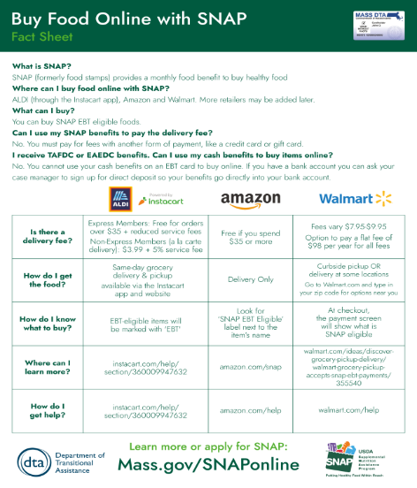
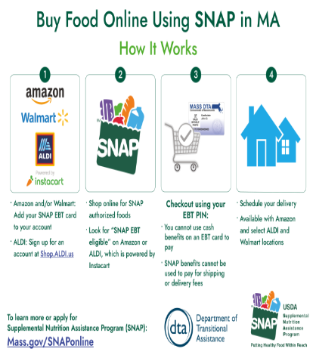
Free Notary Services - all Staff are Notary Publics. Please call 508-693-2896 to set up a time.
Lamination- We are able to laminate certain documents (cards, hunting/fishing licenses etc.) *unfortunately we are unable to laminate your Medicare card – but we can provide a non-sealed laminate pocket for it.
S.H.I.N.E Counseling (Serving Health Information Needs of Everyone) - The objective of SHINE is to ensure that Massachusetts elders have access to objective information, counseling, and assistance on health insurance and health benefit options through a network of trained health benefits counselors, free of charge. Call to schedule an appointment (Open enrollment dates October 15th – December 7th)
Vineyard Isle Parkinsonians Support Group - A Support group for both people suffering from Parkinson’s disease and their caregivers. This group meets the 2nd and 4th Monday of every month at 1:00pm Call the Up Island COA 508-693-2896 for more information.
SNAP (Senior Nutrition Assistance Program- Formerly Food Stamps) - Call the Up Island COA 508-693-2896 to set up an appointment to meet with a staff member to assist with completing an application.
File of Life – We have file of life cards available for pick up. File of life cards are where you can list medication specifics, allergies and other important information that Emergency Personnel are trained to look for. It can make all the difference in frantic situations. It’s best to keep it on your person and also a copy on your fridge- personnel are trained to check these places for medication info!
Durable Medical Equipment Loans- We have equipment available for loaning out. standard aluminum walkers, rollators, crutches, transport wheelchairs, standard wheelchairs, commodes and other items. Please check with us - we are happy to lend you what you will need
DEPENDS: If you or a loved one needs depends under garments or incontinence products please reach out. We have both men’s and women’s that are donated to us. Availability varies as does size, please call ahead to verify we have what you need.
VIRTUAL CLASSES / PROGRAMS
Zoom YOGA w/ Martha Abbot! Martha is hosting an online Zoom yoga class Monday, Wednesday and Friday at 9:15 AM. She opens the “virtual doors” 9:00 AM if people want to chat before class, class starts at 10:30 AM. All are welcome. Email spiritmovesyou@gmail.com for log in information.
Strength Training w/Katryn Gilbert! Katryn is offering her classes via google meet at 9:00 AM and 9:35 AM, 4 times a week! She is hosting 30-minute classes with a mix of strength training and a little cardio. Please email her at Katrynyerdon@prodigy.net for meeting information!

Gentle Yoga w/KANTA on Zoom! While we are sad Kanta is not going to be joining us back in the Howes house, we are happy to share her Gentle Yoga class via Zoom! Tuesday’s at 11:30! Meeting ID 824 4775 7861 Passcode: 709904 Join her via zoom and get back to your yoga practice!

IN PERSON PROGRAMMING

WEEKLY FITNESS WITH MARGARITa kelly Wednesdays at 10AM – Cost $12

CONNI BAKER, ESQ ESTATE AND MEDICAL PLANNING AT THE UP ISLAND COA
2nd (and 4th if needed) Wednesday of the Month. Please call 508-477-4502 to schedule an appointment.
PARKINSON’S GROUP 2nd & 4th .Monday of the month at 1:00 PM – A support group providing an opportunity for people with Parkinson’s to share experiences, new information and updated research. Caregivers are welcome to accompany our people with Parkinson’s and stay for the meeting.

PEDI CARE 4th Monday of the month. Appointments begin at 9:30 AM. Please call to reserve your spot. Toenail maintenance, callus care. No Diabetic foot care. Please note this is NOT a pedicure. Fee $30 ON HIATIS UNTIL APRIL

KNITTER’S GROUP Monday’s 7:00 PM – All are welcome! Contact Ginny at: islandgirlwt@gmail.com

WATERCOLOR GROUP Fridays at 1PM Bring your own supplies and enjoy an afternoon of painting still life with watercolor or medium of your choice.

AUDIOLOGY CLINIC 4th Tuesday of every month 1:30 PM - 3:00 PM Call 508-693-2896 to schedule.

GLEANED GOODS: Due to change of seasons, our selection and abundance changes. Check in with us weekly! Also posted on our Facebook page

BRIDGE AT THE HOWES HOUSE TUESDAYS 2-5 (bring a partner) must email beaphear2@gmail.com to register

ProCRAFTinators 3rd Wednesday of the Month 1:30-2:30 PM Bring your friends!

Zoom YOGA w/ Martha Abbot! Martha is hosting an online Zoom yoga class Monday, Wednesday and Friday at 9:30 AM. She opens the “virtual doors” 9:00 AM if people want to chat before class, class starts at 10:30 AM. All are welcome. Email spiritmovesyou@gmail.com for log in information.

South Coastal Counties Legal Services (CCLS), Attorney Andrew L. Bardetti, serving older adults on Cape Cod & the Islands Older adults interested in signing up for a time slot at your COA contact Ms. Rasheda Dickerson directly at 774-487-3251

Support the Friends of the Up-Island Council on Aging
The Friends of the Up-Island Council on Aging is a 501c3 non-profit fundraising board of volunteers who support the programs and services of the agency. Some examples of how the friends assist the COA and the community are their funding landscaping, providing food and/or fuel assistance to in need Up-Island seniors, and financially supporting many COA events. You can help to assist them in their efforts by contributing. Checks can be made payable to: Friends of UICOA, PO Box 3174, West Tisbury, MA 02575 or if you prefer head over to the *NEW* Friends Website and donate through PayPal. https://friendsofupislandcouncilonaging.org
JANUARY Birthstone:

JANUARY Flower:

JANUARY ZODIAC:
CLOSED MONDAY JANUARY 1
CLOSED MONDAY JANUARY 15
JANUARY QUOTE:

