JULY 2023 NEWSLETTER
The Howes House
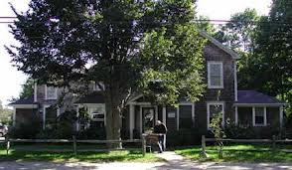Office Hours: Monday – Friday 8:30 AM- 4:00 PM Closed Holidays
IMPORTANT NOTICES:
Please keep your eye on the calendar or call for the latest update.
Please take a look at our virtual program offerings.
IMPORTANT DATES:

CLOSED

1042A State Rd., West Tisbury MA 02575 (Across from Alley’s)
Phone: (508) 693-2896 Fax: (508) 693-1447

Hello friends, ~ Some July highlights include:
- Weekly bring a brown bag lunch Thursdays at 12:30 – we’ll provide dessert
- Discussion Group on the patio Tuesdays 1:30-3
- Bridge at the Howes House Tuesdays 2-5
- ProCRAFTinators 3rd Wednesday of every month 1:30-2:30
- IGI Mobile Market Tuesdays 3-5PM
- NEW Qigong with Nan Doty weekly on Tuesdays starting July 11 - 9am
- July 12th 2:00PM at the Chilmark Library – come say hello to our Outreach Coordinator SUSAN MERRILL and learn about our COA services
- July 20th 11AM Pompeii with an Architect zoom live walking tour
- July 27th Trails MV 1:30PM
Warm regards,
Joyce Albertine, Director
Bethany Hammond, Assistant Director
Susan Merrill, Outreach Coordinator
Jennie Gadowski, Administrative Assistant

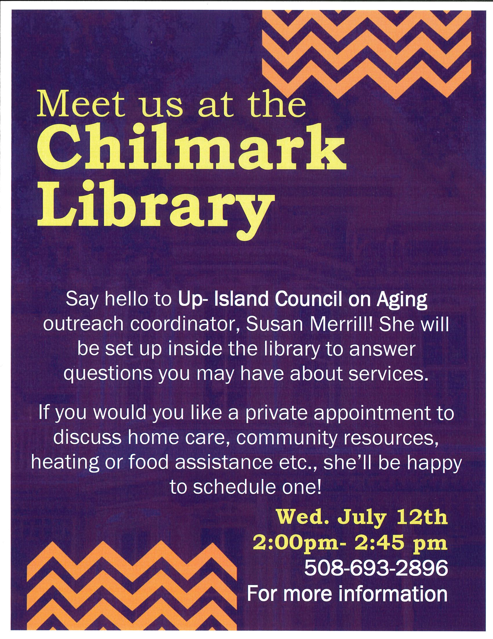
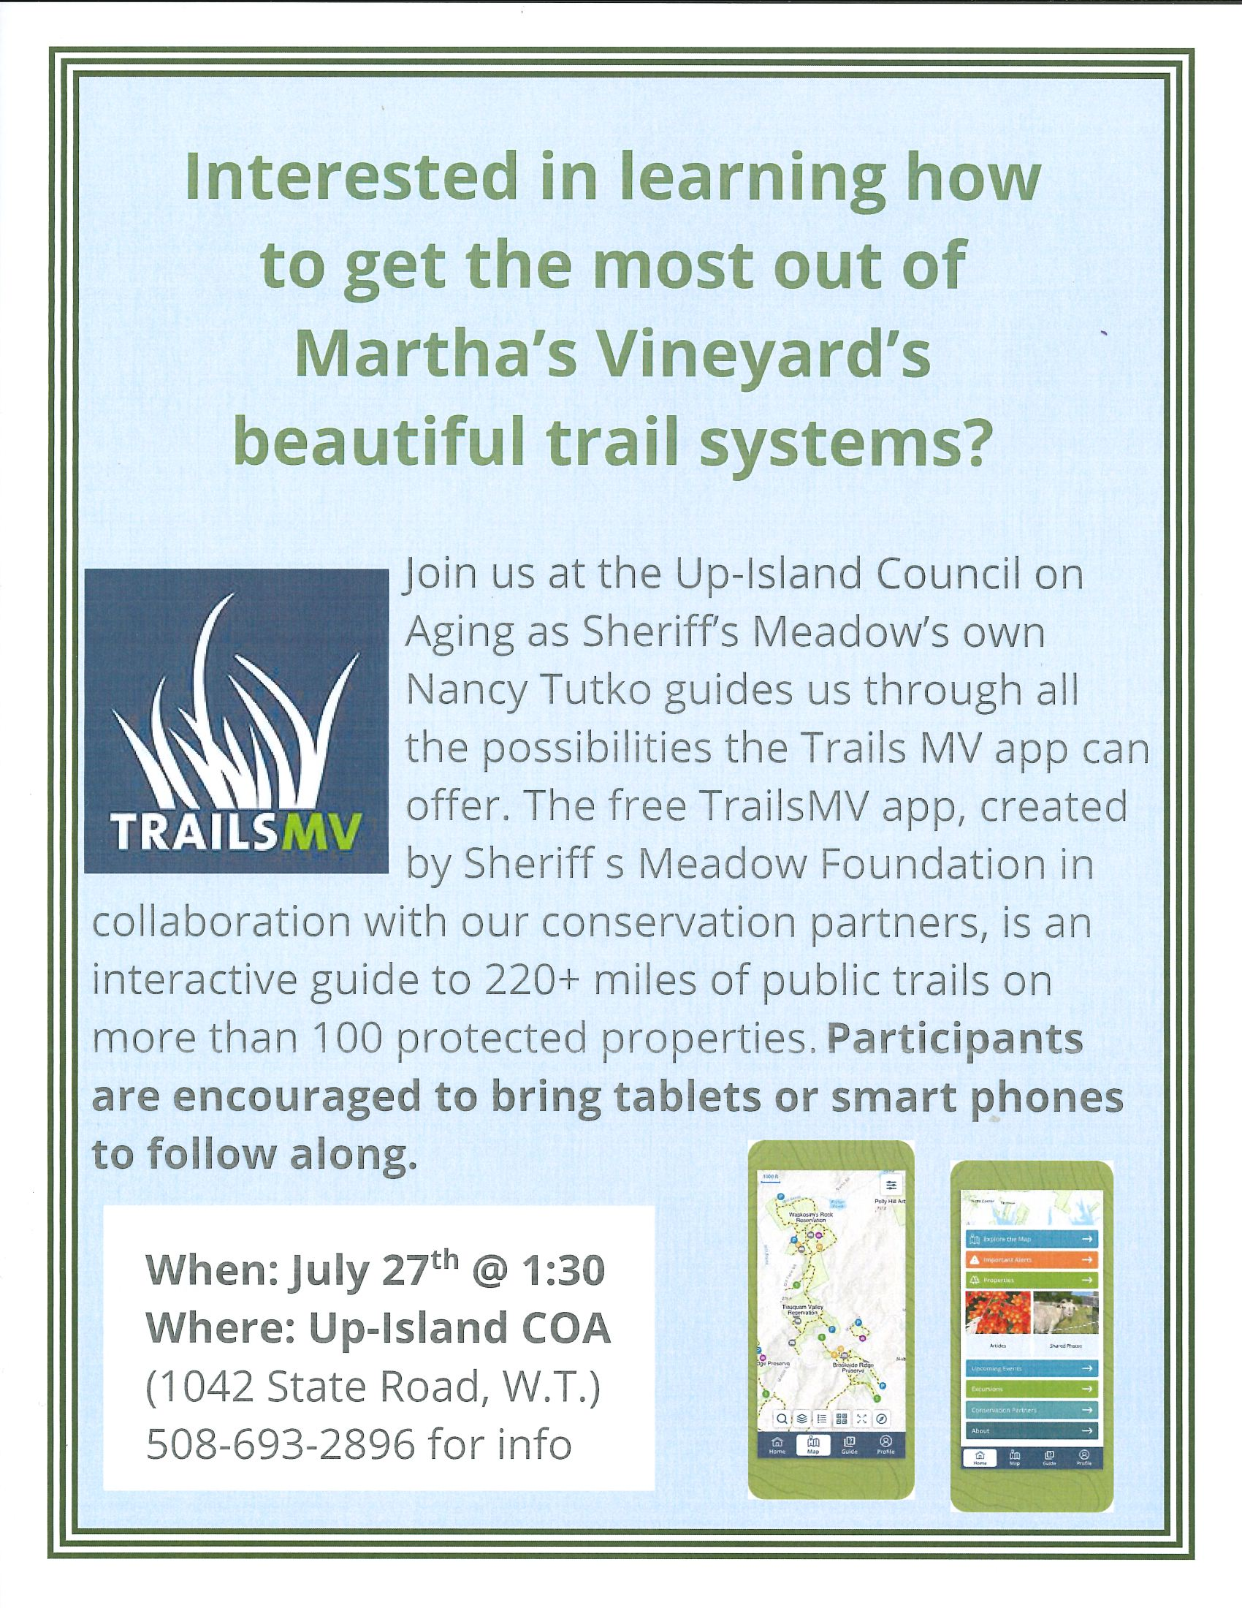
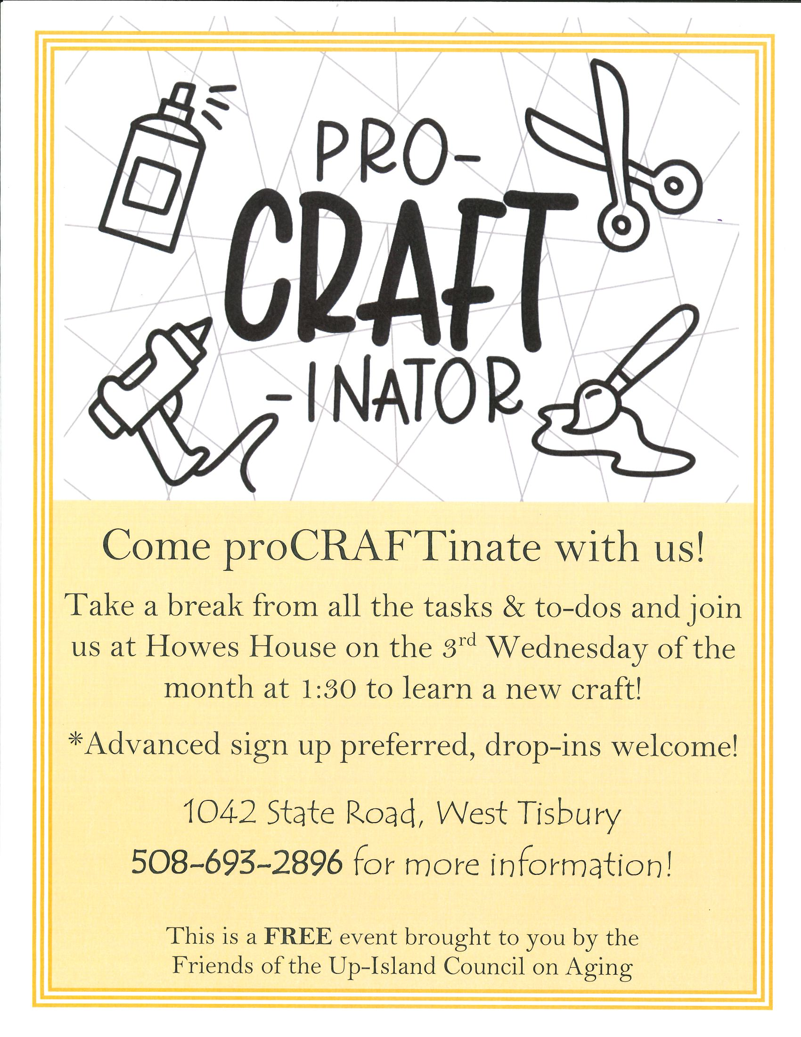 Thursdays at 12:30PM
While we wait for our weekly luncheons to return, we set up the tables in the big room every Thursday at 12:30pm & invite you to bring a bagged lunch to enjoy with friends & good conversation…THE BEST PART??We will provide dessert
Please let us know each week by Tuesday if you plan to attend 508-693-2896

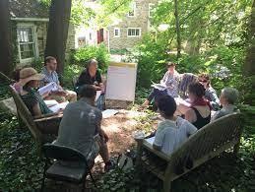
Weekly Discussion Group on the Howes House Patio
(weather permitting) Tuesdays 1:30-3:00

Party Bridge anyone?
We are starting a sign-up sheet
Please call 508-693-2896 Date & time to be determined
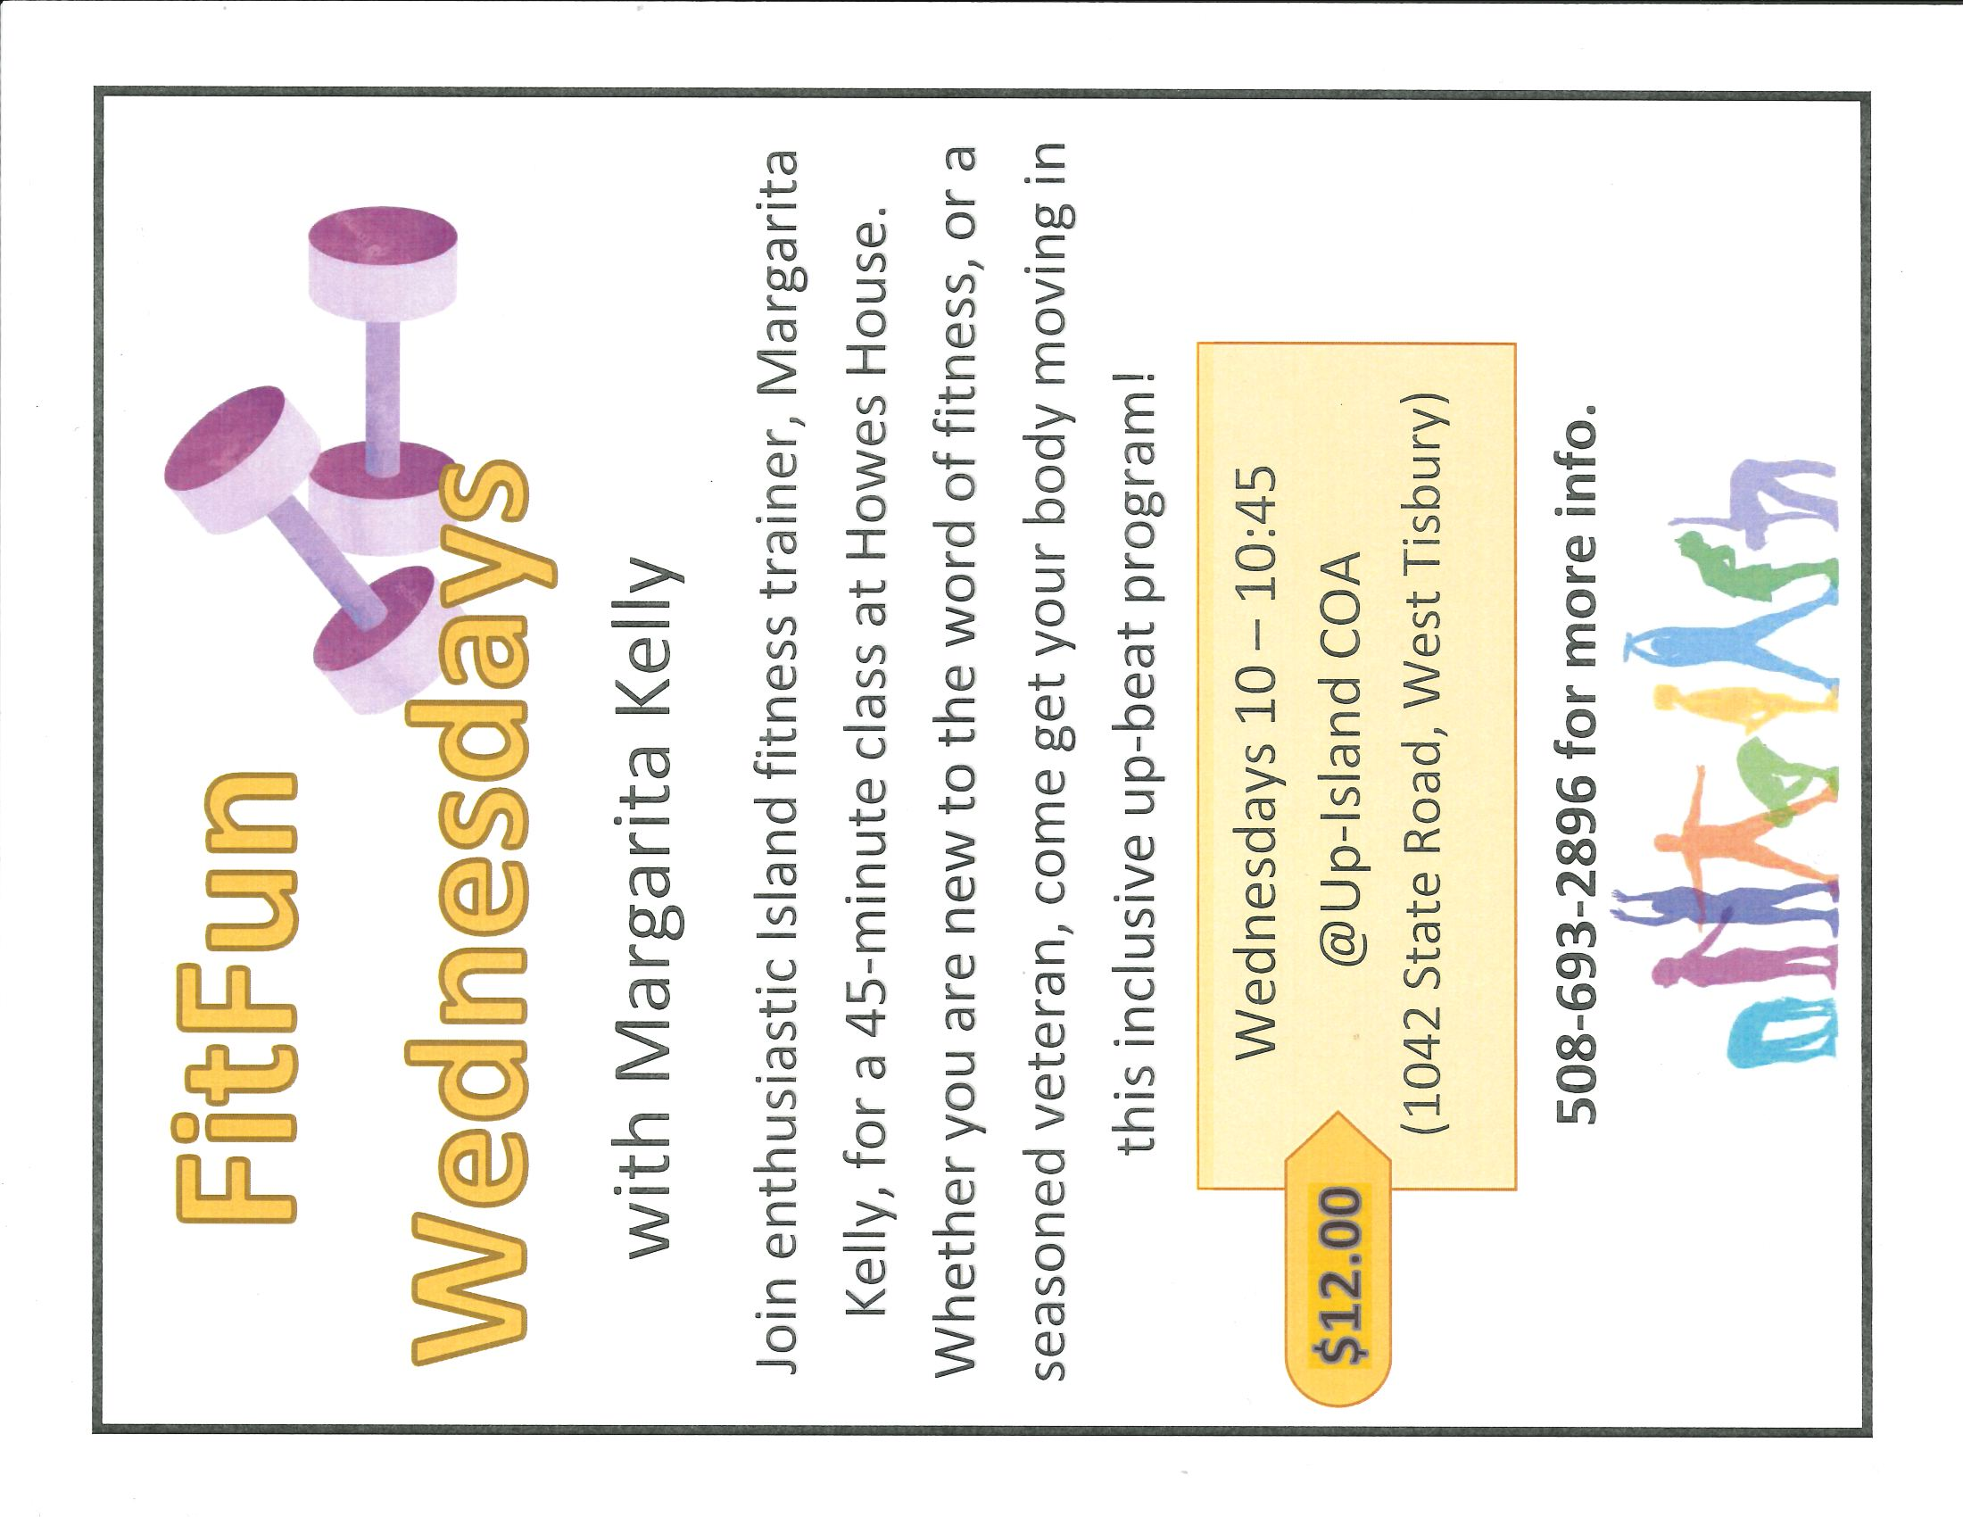
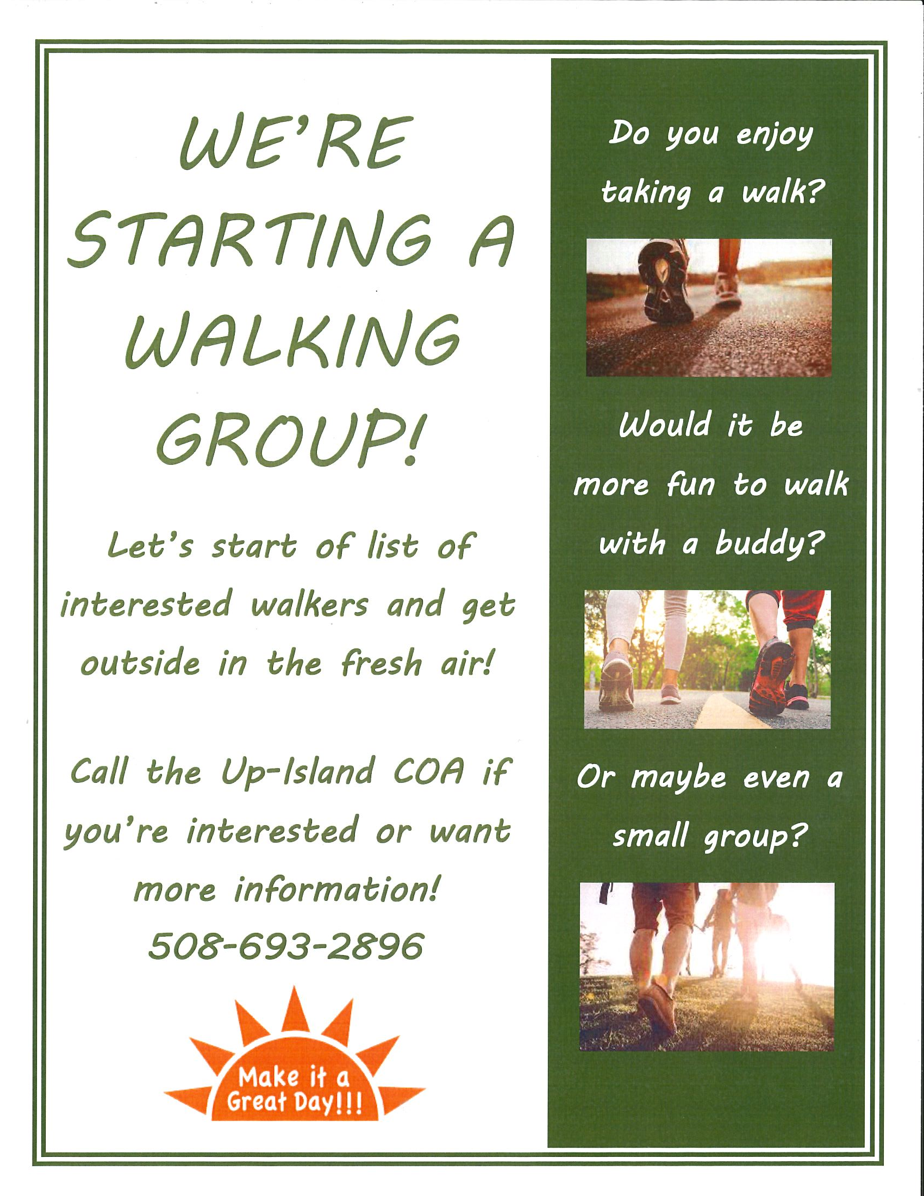

Annual Polly Hill Spring Picnic & Walking Tour June 13, 2023

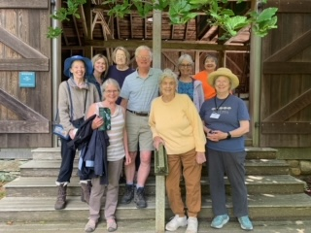

In attendance: Abbie, Susan, Bernadette, David, Lex, Dianne, Leah, Judith, Cheryl (clockwise starting on the left)

SAVE THE DATE!!!

SAVE THE DATE
Join us Saturday November 4th as we travel to the Providence Performing Arts Center for a day of theater and fun!
(Pre-registration required 508-693-2896)

The New York Times calls it “the best musical of this century.” The Washington Post says, “It is the kind of evening that restores your faith in musicals.” And Entertainment Weekly says, “Grade A: the funniest musical of all time.” Jimmy Fallon of The Tonight Show calls it "Genius. Brilliant. Phenomenal." It’s THE BOOK OF MORMON, the nine-time Tony Award® winning Best Musical.
This outrageous musical comedy follows the adventures of a mismatched pair of missionaries, sent halfway across the world to spread the Good Word. With standing room only productions in London, on Broadway, and across North America, THE BOOK OF MORMON has truly become an international sensation. Contains explicit language.

Transportation Services
STOP BY & PICK UP A COPY OF ‘ON THE GO’ SAFE RIDES FOR OLDER ADULTS – SPONSORED BY HEALTHY AGING MV
Go Go Grandparent (Pilot Program from Healthy Aging MV!)
There is a new pilot program called Go Go Grandparent which is fully subsidized to provide on-demand transport for older adults. It is a concierge service that works directly with Uber and Lyft. It does not require that you have an app on your phone - it is all done by a live operator. The Martha’s Vineyard Older Adult Transportation Coalition is piloting this program as well as exploring other solutions for transportation for Older Adults. Please be aware this is piloted towards folks who may not drive anymore and/or meet certain requirements. Contact Cindy Trish at Healthy Aging MV for more info: 508-693-7900 ext. 455

Medivan (VTA)
Medivan to Boston - Tuesdays- 3 times per month call 508-693-9440 ext.1
To participate in the Medivan program, those interested must submit a one-time application through the MVTA. Applications do not require a doctor’s note if passenger is over the age of 60. The Medivan holds 12 passengers and provides service on a first come, first served basis. The van picks up passengers every Tuesday from either the Vineyard Haven Park & Ride at 6:15AM or the VH ferry parking lot at 6:30AM for a 7:00AM ferry to Woods Hole. The van travels to all hospitals within Boston. Doctor’s appointments must be made between 10:00 and 1:00 for a 2:00ish pick-up. Fee is $40.00 round trip, including boat.
Medivan to Ophthalmic Consultants of Boston in Sandwich – One Tuesday per month beginning in January 508-693-7900 ext. 455 or 800-635-0489 (OCB Sandwich office)

VTA Senior Bus Passes
Bus passes are in! Stop by the office to pick yours up! Great news about the passes is that they are now called 365-day passes! So good for a whole year from date of first use! Say you buy it in August- its good until the following August! Passes are $40 and available at the front desk

FOOD RESOURCES:
Surplus Food Distribution the UICOA distributes surplus food sponsored by the Commonwealth of Massachusetts Department of Agriculture. The food to be distributed varies; financial guidelines apply. We try to order a variety of produce and dry goods. Currently our program reaches about 20-25+ senior households in the up-island communities. If you find yourself facing food insecurity, please reach out 508-693-2896
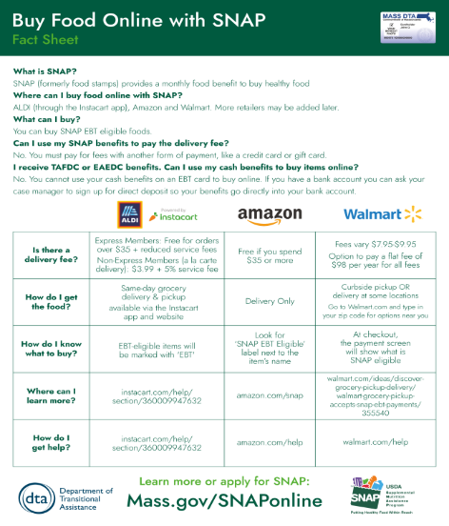
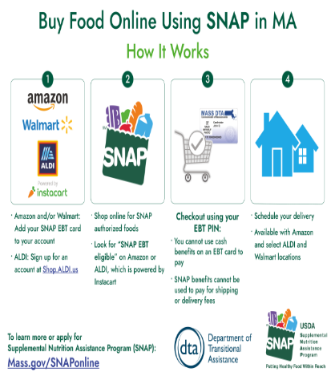
Special Services offered at the Howes House: Below is a list of some of our services.
Free Notary Services - all Staff are Notary Publics. Please call 508-693-2896 to set up a time.
Lamination- We are able to laminate certain documents (cards, hunting/fishing licenses etc.) We can laminate your vaccine card but recommend making a copy first *unfortunately we are unable to laminate your Medicare card – but we can provide a non-sealed laminate pocket for it.
S.H.I.N.E Counseling (Serving Health Information Needs of Seniors) - The objective of SHINE is to ensure that Massachusetts elders have access to objective information, counseling, and assistance on health insurance and health benefit options through a network of trained health benefits counselors, free of charge. Call to schedule an appointment.
Vineyard Isle Parkinsonians Support Group - A Support group for both people suffering from Parkinson’s disease and their caregivers. This group meets the 2nd Monday of every month and is co-facilitated by a registered nurse, a social worker, and a patient. Call the Council for more information.
SNAP (Senior Nutrition Assistance Program- Formerly Food Stamps) - Call the Council on aging to set up an appointment to meet with a staff member to assist with completing an application.
File of Life – We have file of life cards available for pick up. File of life cards are small cards that you can list medication specifics and/or allergies on that EMTs and Paramedics are trained to look for. It can make all the difference in frantic situations. It’s best to keep it on your person and also a copy on your fridge- EMTs are trained to check these places for medication info!
Durable Medical Equipment Loans- We have equipment available for loaning out. At any one time we have the following: standard aluminum walkers, rollators, crutches, transport wheelchairs, standard wheelchairs, commodes and other such items. If you need to an item check with us - we are happy to lend you what you will need! (Please note that Wheelchairs and Rollators are on a 2-month loan program.)
DEPENDS: If you or a loved one is in need of depends under garments or the insert pads for incontinence please reach out. We have an abundance of packages upstairs. We have both men’s and women’s that have been donated to us. Availability varies as does size, please call ahead to verify we have what you need.
VIRTUAL CLASSES / PROGRAMS
Zoom YOGA w/ Martha Abbot! Martha is hosting an online Zoom yoga class Monday, Wednesday and Friday at 9:30 AM. She opens the “virtual doors” 9:00 AM if people want to chat before class, class starts at 10:30 AM. All are welcome. Email spiritmovesyou@gmail.com for log in information. --- monday & friday classes are hybrid (IN PERSON OR ZOOM) from the howes house
Strength Training w/Katryn Gilbert! Katryn is offering her classes via google meet at 9:00 AM and 9:35 AM, 4 times a week! She is hosting 30-minute classes with a mix of strength training and a little cardio. Please email her at Katrynyerdon@prodigy.net for meeting information!

Gentle Yoga w/KANTA on Zoom! While we are sad Kanta is not going to be joining us back in the Howes house, we are happy to share her Gentle Yoga class via Zoom! Tuesday’s at 11:30! Meeting ID 824 4775 7861 Passcode: 709904 Join her via zoom and get back to your yoga practice!

IN PERSON PROGRAMMING

WEEKLY FITNESS WITH MARGARITa kelly Wednesdays at 10AM – Cost $12

CONNI BAKER, ESQ Estate and Medicaid planning @ the UP ISLAND COA
2nd (and 4th if needed) Wednesday of the Month. Please call 508-477-4502 to schedule an appointment.
PARKINSON’S GROUP 2nd Monday of the month at 1:00 PM – A support group providing an opportunity for people with Parkinson’s to share experiences, new information and updated research. Caregivers are welcome to accompany our people with Parkinson’s and stay for the meeting.

PEDI CARE 4th Monday of the month. Appointments begin at 9:30 AM. Please call to reserve your spot. Toenail maintenance, callus care. No Diabetic foot care. Please note this is NOT a pedicure. Fee $30

DISCUSSION GROUP ON THE HOWES HOUSE PATIO (Weather permitting)
Weekly Tuesdays 1:30-3:00 PM Join in us for Open Discussions of Controversial and Contemporary subjects, Group meets outside on our patio or inside weather dependent. All are welcome!

KNITTER’S GROUP Monday’s 7:00 PM – All are welcome! Contact Ginny at: islandgirlwt@gmail.com

WATERCOLOR GROUP Fridays at 1PM Bring your own supplies and enjoy an afternoon of painting still life with watercolor or medium of your choice.

AUDIOLOGY CLINIC 4th Tuesday of every month 1:30 PM - 3:00 PM Call 508-693-2896 to schedule Appointments will be booked 1 person every ½ hr.

GLEANED GOODS: Due to change of season, our selection and abundance changes. Check in with us on Tuesdays around Noon to see what goodies have been delivered that day! Also posted on our Facebook page

BRIDGE AT THE HOWES HOUSE TUESDAYS 2-5 (bring a partner) must email beaphear2@gmail.com to register

ProCRAFTinators 3rd Wednesday of the Month 1:30-2:30 PM Bring your friends!

South Coastal Counties Legal Services (CCLS), Attorney Andrew L. Bardetti, serving older adults on Cape Cod & the Islands Older adults interested in signing up for a time slot at your COA contact Ms. Rasheda Dickerson directly at 774-487-3251
Support the Friends of the Up-Island Council on Aging The Friends of the Up-Island Council on Aging is a 501c3 non-profit fundraising board of volunteers who support the programs and services of the agency. Some examples of how the friends assist the COA and the community are their funding landscaping, providing food and/or fuel assistance to in need Up-Island seniors, and financially supporting many COA events. You can help to assist them in their efforts by contributing. Checks can be made payable to: Friends of UICOA, PO Box 3174, West Tisbury, MA 02575 or if you prefer head over to the *NEW* Friends Website and donate through PayPal. https://friendsofupislandcouncilonaging.org

JULY Birthstone:
JULY Flower:
JULY ZODIAC:
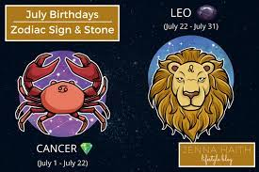

JULY HOLIDAYS & SPECIAL EVENTS:
HOWES HOUSE CLOSED
JULY QUOTE:

