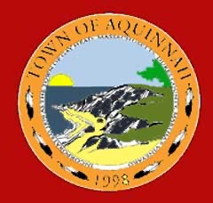
Town of Aquinnah
Aquinnah Building Committee (ABC) – Public Meeting
Town Hall / Police Department / Town Offices/ Comfort Stations
Date: Thursday 04/06/23
Location: Town Hall
Time: 4:00 pm
Attendees: ABC Members

Item # | Agenda Item | Action
1  2 | Call Meeting to Order:  A. Chair informs committee and audience this is a public meeting.
Public Comments:
A. Introduce themselves with name + address
B. Comments limited to two minutes per person
.

3 | New Business & General Discussion:  - Circle Restroom Existing Building: Adrian  - Define scope of work for operation 2023 season.  - Walkthrough with various trades – Ballpark pricing  - Assessment by Building Inspector – Low Scope  - Cost estimate + Alternative Options – Next Steps  - Town Hall: Adrian  - Facilities maintenance for high priority issues  - Define issue and maintain costs to present at ATM  - Discussion: Proposed new process for management of Town Facilities.
4 | Other Business Not Reasonably Anticipated within 48 Hours of Meeting.
5 | Upcoming Meeting(s):  - Community Meetings XX-XX-2023 (tbd)  - ABC Meetings XX-XX-2023 (tbd)  - Meeting w/BOS XX-XX-2023 (tbd)
6 | Meeting Adjourned

