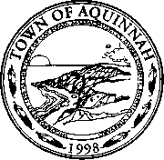

Meeting of the Aquinnah Conservation Committee

Sarah Thulin
Steve Yaffe
Mary Elizabeth Pratt
Sibel Suman
Kathy Newman

AQUINNAH CONSERVATION COMMISSION
On January 14, 2020 at 4 PM a public hearing will be held in the Aquinnah town offices under the Massachusetts Wetlands Protection Act and the Aquinnah Wetlands/Water Resource Bylaw to act on a Notice of Intent filed by Oliver Crowell for the replacement of an existing cabin with a single family dwelling plus the installation of underground utilities and associated site work within 200 feet of a Riverfront area.
Location: Lobsterville Road Map 4 Parcel 12.1
Site visit: January 14, 2020 at 3:15 PM

